**CREATIVE EDUCATIONAL SERVICES KAMPALA**

**MID-TERM I EXAMINATIONS 2024**

**LEARNING AREA 4: MATHEMATICAL CONCEPTS**

**TOP CLASS**

**Name: .............................................................................. ….. Stream: ....................................................................................**

1. **Count and circle the correct number.**

= 3 2 1

= 6 3 1

= 5 2 0

= 3 2 1

= 1 2 7

1. **Count the beads.**

= = = =

1. **Write numbers 0 – 10**

0

1. **Match the shapes to the words.**

Oval

Circle

kite

circle

triangle

1. **Form sets**

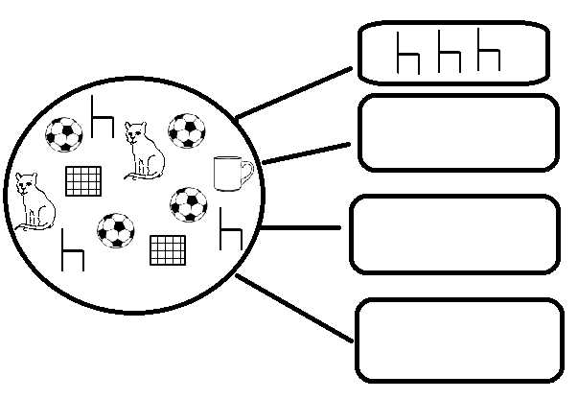

1. **Match the same set.**

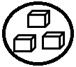 

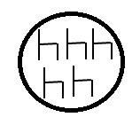 

 

 

1. **Underline the correct word.**

0 zero orez

1 neo one

2 wto two

3 three eethr

4 rouf four

1. **Put together the objects.**

+ =

  +   =

HH01672_ HH01672_ HH01672_ + HH01672_ HH01672_ =

 +  =

+ =

9- **Take away objects**

=

    =

    =

BD07837_ BD07837_ BD07837_ BD07837_ BD07837_ =

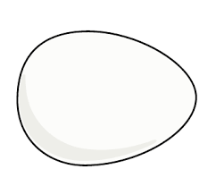 =

1. **Add these numbers horizontally**.

3 + 1 = 2 + 2 =

3 + 2 = 1 + 1 =

**END**